SPARSH MAGIC
INTERNAL RECRUITMENT POLICY & SOP
(Hiring for Sparsh Magic's Own Vacancies — Internally-Owned Budget)

Field | Detail
Policy Name | Sparsh Magic Internal Recruitment Policy & Standard Operating Procedure
Policy Owner | Human Resources Department
Applicable To | Department Heads, HR team, and Management involved in filling Sparsh Magic's own internal vacancies
Approved By | Management / Directors
Version | 1.0
Effective Date | To be notified
Confidentiality | Internal Use Only — not to be shared outside the organization without HR/Management consent
Document Status | Implementation-ready

Table of Contents
1. Purpose & Scope
2. Roles & Responsibilities
3. Internal Requisition & Budget Approval
4. Internal Approval Matrix
5. Sourcing, Screening & Interview Process
6. Reference Check, Offer & Joining
7. Induction, Probation & Documentation
8. Internal Recruitment Timeline / SLA
9. Recruitment Documentation
10. Recruitment KPIs
11. Compliance Requirements
12. Exceptions
13. Record Management
14. Policy Review Process
Annexure A — Recruitment Process Flow (Visual)
Annexure B — RACI Matrix
Annexure C — Efficiency & Candidate Experience Recommendations

PART B — Sparsh Magic Internal Recruitment
Entirely New Part: This part governs hiring for Sparsh Magic's own vacancies (not client roles). The key difference from Part A is that budget, headcount, and salary band are owned and approved internally by Sparsh Magic Management/Finance — there is no client in this process. [NEW – Added from Best Practice]

1. Purpose & Scope
This part establishes a structured process for filling Sparsh Magic's own internal vacancies — across functions such as HR, Operations, Accounts, Admin, and any internal leadership roles — ensuring the same discipline (approved requisition, scorecard-based evaluation, documented decisions) applied to client recruitment is applied internally.

2. Roles & Responsibilities
Role | Responsibility
Department Head (HOD) | Raises the internal requisition; defines role requirement; participates in panel interview and final selection.
HR Team | Owns end-to-end delivery: JD/scorecard preparation, sourcing, screening, interview coordination, offer processing, onboarding.
Management / Finance | Approves headcount and budget before sourcing begins; approves final offer for managerial and above roles.
Candidate | Provides accurate information and completes joining formalities.

3. Internal Requisition & Budget Approval
Step 1 — Internal Manpower Requisition: The Department Head raises a requisition specifying role, reporting line, and business justification.
Step 2 — Headcount & Budget Approval: Unlike PRO-fit (where the client owns the budget), here the salary band and headcount must be approved internally by Sparsh Magic Management/Finance before any sourcing begins. No internal role may be sourced without this written approval.
Step 3 — Position Scorecard: HR prepares the scorecard (skills, experience, culture-fit expectations) and gets it approved by the HOD and, for managerial and above roles, by Management.

4. Internal Approval Matrix
Activity | HR | Department Head | Management/Finance
Raise requisition | Verify | Initiate/Approve | Inform
Headcount & budget approval | Recommend | Recommend | Approve (mandatory)
Position Scorecard | Draft | Approve | Approve (managerial+)
Shortlist review | Prepare | Approve | Inform
Final interview (managerial+) | Coordinate | Participate | Approve
Offer approval | Verify budget compliance | Recommend | Approve (mandatory)
Offer release | Issue | Inform | Inform
Probation confirmation | Recommend | Approve | Inform (managerial+)

5. Sourcing, Screening & Interview Process
- Sourcing channels: internal database, job portals, employee referrals; executive search for leadership roles with Management approval.
- Screening: CV validation against scorecard, followed by a brief telephonic screening by HR.
- Assessment: role-relevant skill/competency test where applicable.
- Panel interview: HR + Department Head for junior/mid roles; add Management for senior/managerial roles.
- Internal shortlisting committee (HR + HOD) finalizes candidates using the same scoring guide as Part A (4.0+ strong, below 3.0 reject).
- Final interview with Management for managerial and above roles before offer stage.

6. Reference Check, Offer & Joining
- Reference check completed before offer for all roles (not limited to managerial+, since Sparsh Magic bears the direct employment risk internally).
- Salary negotiation must stay within the internally approved budget from Step 2; any deviation requires fresh Management/Finance approval.
- Offer letter is issued by Sparsh Magic HR directly (there is no client to issue it).
- Pre-boarding engagement and joining acknowledgement follow the same practice as Part A.

7. Induction, Probation & Documentation
- Induction: company policies, systems/access setup, introductions — coordinated by HR on Day 1.
- Probation review: formal check-in and confirmation decision at the end of the probation period (typically 3–6 months, per employment terms).
- Personnel file: offer letter, joining documents, verification reports, and probation confirmation are filed and closed by HR.
Since there is no client handover in this vertical, the requisition is closed internally once probation confirmation is recorded. [NEW – Added from Best Practice]

8. Internal Recruitment Timeline / SLA
Milestone | Target Timeline
Budget/headcount approval | Within 3 working days of requisition
Position Scorecard approved | Within 2 working days of budget approval
Shortlist ready for HOD review | Within 15 working days
Offer released after final selection | Within 3 working days
Induction completed | Day 1 of joining
Probation review completed | Before end of probation period

9. Recruitment Documentation
Standard templates to be maintained for every internal requisition:
- Internal Manpower Requisition Form
- Headcount & Budget Approval Note (Management/Finance)
- Position Scorecard / Job Description
- Candidate screening & interview scorecards
- Reference check report
- Offer Confirmation & Acceptance Record
- Induction checklist
- Probation review & confirmation record
- Personnel file closure note

10. Recruitment KPIs
KPI | Recommended Target
Requisitions with approved budget before sourcing | 100%
Shortlist ready within TAT (Day 15) | 95%+
Offer-to-joining conversion rate | Track monthly
Reference check completed before offer | 100%
Offer letter issued before joining date | 100%
Probation confirmation completed on time | 95%+
90-day retention of new joinees | Track monthly
New-hire satisfaction / induction feedback score | Track quarterly

11. Compliance Requirements
- Candidate personal data (CVs, interview notes, verification reports) must be used only for the recruitment purpose and stored securely with access limited to HR.
- Recruitment must not discriminate on grounds of gender, religion, caste, region, or disability unrelated to role requirements.
- No internal role may be sourced without prior written headcount and budget approval from Management/Finance.
- Statutory pre-employment checks (identity, education, prior employment) applicable to the role/location must be completed before confirmation.

12. Exceptions
Any deviation from this policy — extended TAT, relaxed scorecard criteria, offer outside approved budget, waiver of reference check — must be recorded in an Exception Log with reason, approver, and date. Exceptions beyond HR/Department Head authority require Management/Finance approval.

13. Record Management
Record Type | Minimum Retention Period
Requisition & budget approval records | 3 years from requisition closure
Candidate scorecards & interview records (selected candidates) | 3 years from joining, then as part of personnel file
Candidate records (not selected) | 1 year, then securely purged
Offer & acceptance records | Duration of employment + 3 years
Reference check reports | Duration of employment + 3 years
Probation confirmation records | Duration of employment + 3 years

14. Policy Review Process
This policy shall be reviewed annually, or earlier if triggered by KPI underperformance, organizational restructuring, or a change in internal hiring needs. Review shall be led by HR and approved by Management. All amendments shall be logged in the Modification History table.

Annexure A — Internal Recruitment Process Flow (Visual)
The diagram below shows the complete internal recruitment flow, from requisition through probation confirmation.
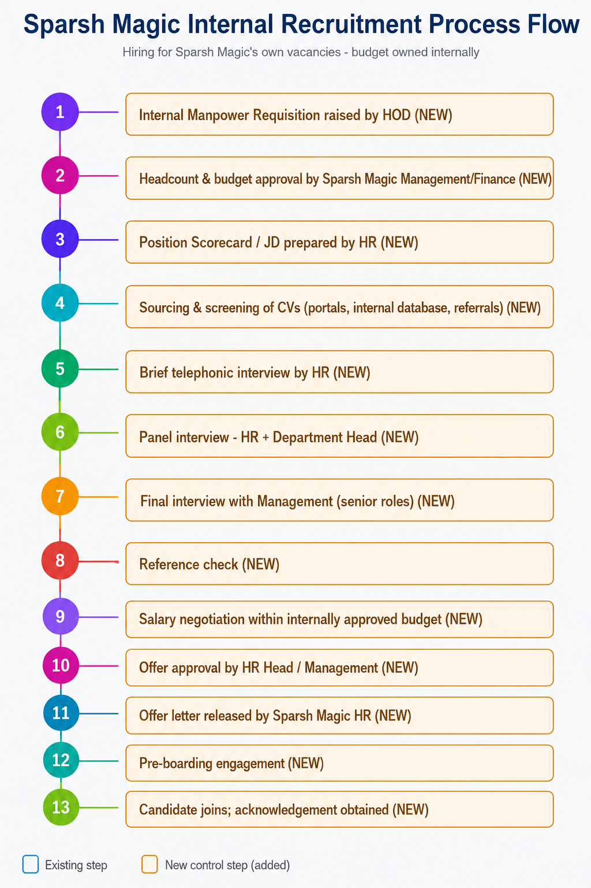

Annexure B — RACI Matrix
Recruitment Stage | HR | Department Head | Management/Finance
Raise internal requisition | C | R | I
Headcount & budget approval | C | C | A/R
Position Scorecard / JD | R | A | C (managerial+)
Recruitment planning / sourcing strategy | R | I | I
Sourcing & screening | R | I | I
Telephonic screening | R | I | I
Skill/competency assessment | R | C | I
Panel interview | R | A | C (managerial+)
Internal shortlisting committee | R | A | I
Final interview (managerial+) | C | C | A/R
Reference check | R | I | I
Salary negotiation | R | C | A
Offer approval | C | C | A
Offer release | R | I | I
Pre-boarding engagement | R | I | I
Joining & induction | R | C | I
Probation review & confirmation | C | A/R | I (managerial+)
Personnel file closure | R | I | I
KPI / dashboard reporting | R | I | A
Exception approval | C | C | A
Policy review | R | C | A
Legend: R = Responsible, A = Accountable, C = Consulted, I = Informed

Annexure C — Suggestions to Improve Efficiency and Candidate Experience

Efficiency
- Maintain a shared internal requisition tracker (status, scores, budget approval date) visible to HR, Department Head, and Management.
- Pre-define standard salary bands per role/grade with Finance annually, so individual requisitions don't need a fresh budget discussion each time.
- Batch internal panel interviews (e.g., fixed weekly interview slots) to reduce scheduling overhead with Department Heads.
- Build and maintain an internal talent pool of prior applicants and referrals to speed up sourcing for recurring role types.
- Automate SLA breach alerts (e.g., Day 3 budget approval, Day 15 shortlist) so HR escalates proactively.

Candidate Experience
- Acknowledge every internal application within a defined window and give candidates a clear status-update cadence.
- Communicate rejections with basic closure rather than leaving candidates without a response.
- Confirm interview logistics (panel, duration, mode) at least 24 hours in advance.
- Provide a clear written offer summary before the formal offer letter so candidates can plan their transition.
- Continue pre-boarding engagement between offer acceptance and joining to reduce drop-outs.
- Collect a short new-hire experience survey at the end of induction and again at probation confirmation, feeding into the KPI dashboard.

